{Course: Keep My Child Safe and Healthy}

{Lesson: Teaching Safe Touch (Age 2-5/M & F) video title:safe_touch_2to5_yc - make duplicate one m one f}
Script | On Slide Text | Animation Notes
Hi, you’re back on ParentText, fantastic!  This course is about keeping your child safe and healthy. Today, we will talk about teaching your child safe and unsafe touch.  Here are four helpful tips to guide you in teaching your child about safe and unsafe touch and what to do if they ever feel uncomfortable when someone touches them.  Let’s learn more together! | Teach Safe Touch
First, learn about private parts.  Teach your child that the parts of their bodies that go under their underwear or a swimsuit are private parts. It is not okay for other people to touch or look at their private parts  [pause]  It is also not okay for someone to ask your child to touch or look at someone else’s private parts.  [pause]  Second, teach your child that it’s okay to say no.  Tell your child that they are always allowed to say no to someone touching them even if they are family or friends. This is true even for things like hugs! This teaches your child that they are always in control of who they allow to touch them so they can make safe choices throughout their lives, in any situation. You can practise saying “No, please don’t do that” and “No! Stop!” with your child so they know how to do it if they need to.  The next tip is to get away.  Teach your child how to get away from any situation where they feel uncomfortable. Offenders are usually known to the child and/or caregivers and initially engage in physical activities like wrestling or touching. This is to get the child comfortable with touch. When you are playing physical games like wrestling with your child, practise saying "no" and respecting their boundaries. If your child says "no", stop the game immediately.  [pause]  This empowers them to say “NO!” to unsafe situations outside the home as well.  It will not be as easy for the child to get away from such situations, but teaching them how to leave when they feel uncomfortable will help.  [pause]  Finally, teach your child to tell an adult.  Tell your child that if they feel worried, uncomfortable, or unsafe about anyone touching them, they should tell you or an adult they trust. Always believe your child when they tell you about someone touching them in an unsafe way.  [pause]  If your child tells you about something that has happened, listen openly and tell them they were right to tell you. Then, take steps to keep them safe. Always believe your child, and don’t leave them alone with the person they feel unsafe with. | LEARN ABOUT PRIVATE PARTS  “NO” IS OK!  GET AWAY  TELL AN ADULT | Animate words to text
Remember, to teach your child about safe and unsafe touch, follow the four tips - learn about private parts, saying “no” is okay, how to get away, and tell an adult.  Your home activity is to have a conversation with your child about safe and unsafe touch. Help them practise saying, “No, don’t do that!” or “No! Stop!” and remind them to tell an adult if it happens.  Can you do this with your child today? | Teaching Safe Touch  LEARN ABOUT PRIVATE PARTS  “NO” IS OK!  GET AWAY  TELL AN ADULT  Home Activity:  Have a conversation about safe and unsafe touch.

{Lesson: Teaching Safe Touch (Age 6-9)}
Script | On Slide Text | Animation Notes
Hi, you’re back on ParentText, fantastic!  This course is about keeping your child safe and healthy. Today, we will talk about teaching your child safe and unsafe touch.  Here are five tips to help you teach your child about safe touch and what to do if they feel unsafe when someone touches them.  Ready to learn more? | Teach Safe Touch
The first tip is, be honest.  Talk to your child about how to name each part of their body. If your child knows how their body works and where people should and should not touch them, they can make safer choices throughout their lives.  Answer any question your child asks you honestly. These could be about any part of their own body or that of the other sex - even private parts!  This teaches them it is safe to ask about the body, which means they will learn more and stay safer.  Teaching your child about their whole body, even when young, means they will know how to talk about it if anything happens that they feel is unsafe. | BE HONEST about how to name body parts and how bodies work
The second tip is to teach your child that it’s okay to say no.  Tell your child that they are always allowed to say no to someone touching them even if they are family or friends. This is true even for things like hugs!  This teaches your child that they are always in control of who they allow to touch them so they can make safe choices throughout their lives, in any situation.  You can practise saying “No, please don’t do that” and “No! Stop!” with your child so they know how to do it if they need to. | “NO” IS OK!  practise saying “No, please don’t do that” and “No! Stop!”
The third tip is to get away.  Teach your child how to get away from any situation where they feel uncomfortable. In most of the cases, offenders are not strangers to the child. Offenders are usually known to the child and/or caregivers and initially engage in physical activities like wrestling or touching. This is to get the child comfortable with touch.  When you are playing physical games like wrestling with your child, practise saying "no" and respecting their boundaries. If your child says "no", stop the game immediately.  This empowers them to say “NO!” to unsafe situations outside the home as well. It will not be as easy for the child to get away from such situations, but teaching them how to leave when they feel uncomfortable will help. | GET AWAY from situations where your child feels uncomfortable
Next, tell an adult.  Tell your child that if they feel worried, uncomfortable, or unsafe about anyone touching them, they should tell you or an adult they trust.  [pause]  If your child tells you about something that has happened, it is important that you listen openly and tell them they were right to tell you. Then, take steps to keep them safe. Always believe your child, and don’t leave them alone with the person they feel unsafe with. | TELL AN ADULT about anything uncomfortable or unsafe
Remember, to teach your child about safe and unsafe touch, follow the five tips - be honest, saying “no” is okay, how to get away, tell an adult, and get help.  Your home activity for today is to have a conversation with your child about safe and unsafe touch. Help them practise saying, “No, don’t do that!” and remind them to tell an adult if it happens.  Can you do this with your child today? | Teach Safe Touch  BE HONEST  “NO” IS OK!  GET AWAY  TELL AND ADULT  RESPOND  HOME ACTIVITY  Have a conversation about safe and unsafe touch.

{Lesson: Community Safety (2-4)}
Script | On Slide Text | Animation Notes
Hello, it is great to see you again on ParentText!  This lesson is about learning how to keep Your child safe in your community.  One thing you can do to help keep your child safe is to talk with them about which places are safe to go and which are not, and teach them how to be careful when they meet people they don't know.  Here are four steps to help you with this conversation:  Draw  [pause]  talk,  [pause]  discuss,  [pause]and practise.  Let’s learn more together! | Community Safety  DRAW  TALK  DISCUSS  practise
The first step is to DRAW.  With your child, draw a map of your community. Include all the main places in your community on the map, like your house, streets in your neighbourhood, crèche, and other places you and your child might go to. [1]  Draw and identify pictures of trusted people who your child can go to when they feel unsafe. These can be you and your partner, other family members, or their teachers. | DRAW | Begin with a blank sheet. Animate on [1]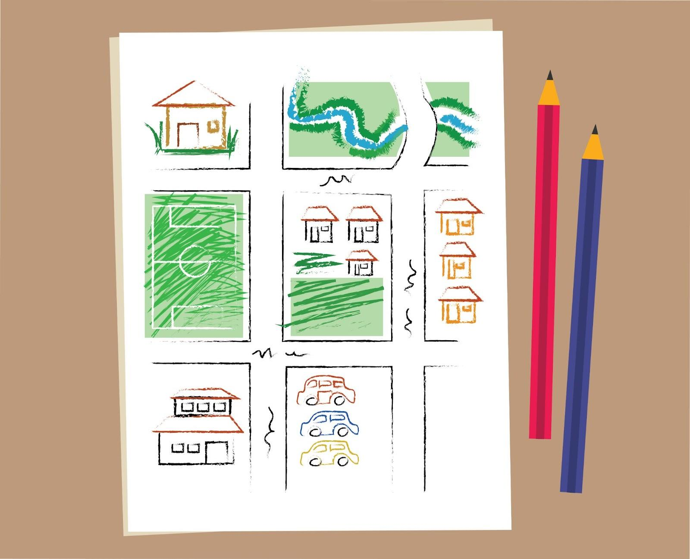
The next step is to TALK.  Talk about the safe and unsafe places on your map. For example, let your child know that the street is not a safe place, even if their toy or ball goes there.  [1] CIRCLE the places that are safe for children. CROSS OFF any places that are unsafe for your child. For example, tuck shops, taxi ranks, or unfamiliar or unoccupied buildings. | TALK | Begin with the previous sheet. Animate on [1]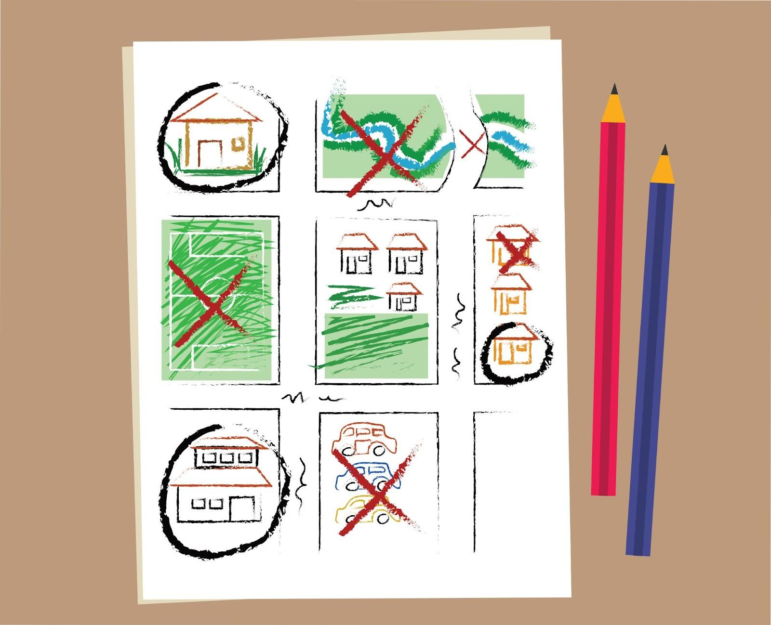
The third step is to DISCUSS. Discuss with your child why it is important to ALWAYS have an adult with them when they go outside. Make sure your child knows it’s okay to walk or run inside if a stranger tries to talk to them or asks them to go somewhere. Discuss with your child safe places they can run if a stranger approaches them – such as your home, or a neighbour’s home.  [1] Mark these areas clearly with a star on your map. | DISCUSS | Begin with the previous sheet. Animate on [1]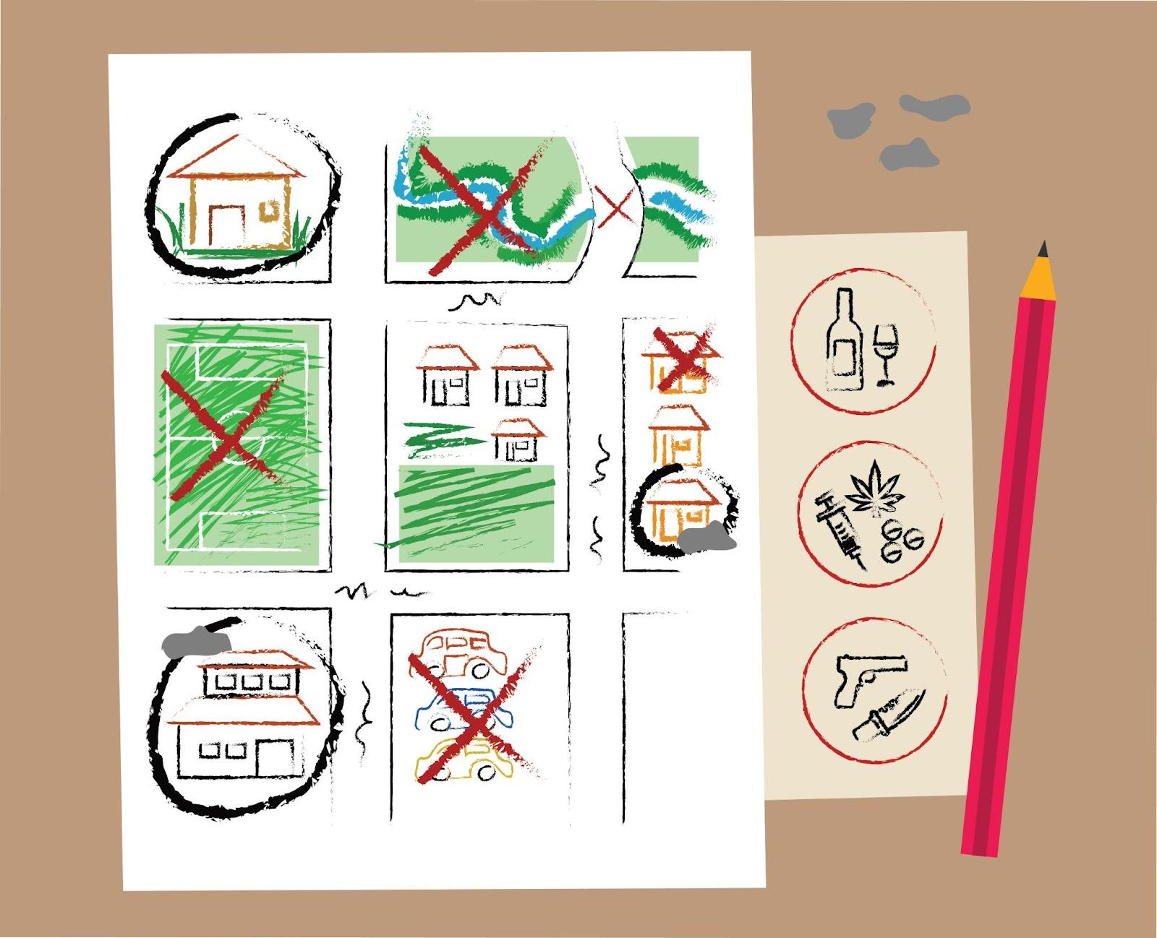
The last step is to practise, practise, practise!  Using toys or puppets, role-play scenarios where a stranger approaches. Ask your child what the toy should do. Children find it less scary to pretend that someone else is in danger.  Remember to praise them when your child chooses the correct response, such as running away, shouting for help, or finding a trusted adult. | PRACTISE  Role-play using toys or puppets  Remember to praise
Talking about unsafe situations with your child might feel uncomfortable, but it's important. When children know what to do in a dangerous situation, they're much safer.  Your home activity is to have a conversation with your child about which places are safe or unsafe for children in your community. Do you have time to do it today? | Community Safety  HOME ACTIVITY  Have a conversation with your child about safe and unsafe places in your community

{Lesson: Community Safety (5-9)}
Script | On Slide Text | Animation Notes
Hello! This course is all about keeping your child safe and today we are learning about community safety.  One thing you can do to help keep your child safe is to talk with them about which places are safe to go and which are not, and teach them how to be careful when they meet people they don't know.  Here are four steps to help you with this conversation:  Draw  [pause]  talk,  [pause]  discuss,  [pause]and practise.  Let’s learn more together! | Community Safety  DRAW  TALK  DISCUSS  practise
The first step is to DRAW.  With your child, draw a map of your community. Include all the main places in your community on the map, like your house, streets in your neighbourhood, school, shops, and other places you and/or your child might go to. [1]  Draw and identify pictures of trusted people who your child can go to when they feel unsafe. These can be you and your partner, other family members, or their teachers. | DRAW | Begin with a blank sheet. Animate on [1]
The next step is to TALK.  Talk about the places on your map and decide if they are safe or not.  Make sure you listen to your child. It is important to understand why they think a place is safe or unsafe.  [1] CIRCLE the places that are safe for children. CROSS OFF any places that are unsafe for your child. For example, areas under construction, parking areas, or unfamiliar buildings. | TALK | Begin with the previous sheet. Animate on [1]
The third step is to DISCUSS.  Sometimes, we find ourselves in trouble. Make sure your child knows it’s okay to walk or run inside if a stranger tries to talk to them or asks them to go somewhere. Discuss where you and your child can get support in a crisis. These places may include home, school, a police station, or a clinic.  [1] Mark these areas clearly with a star on your map. | DISCUSS | Begin with the previous sheet. Animate on [1]
Finally, practise! practise! practise!  Role-play scenarios where a stranger approaches using toys or puppets. Ask your child what the toy should do. Children find it less scary to pretend that someone else is in danger. Praise them when your child chooses the correct response, such as running away, shouting for help, or finding a trusted adult. | PRACTISE  Role-play using toys or puppets  Remember to praise
Talking about unsafe situations with your child might feel uncomfortable, but it's important. When children know what to do in a dangerous situation, they're much safer.  Your home activity is to have a conversation with your child about which places are safe or unsafe for children in your community. Give space for your child to share their thoughts, too. They may think a place is unsafe that you thought was safe. Allow them to explain their reasons. Do you have time to do it today? | Community Safety  HOME ACTIVITY  Have a conversation with your child about safe and unsafe places in your community

{Lesson: Responding to Crises (2-6)}
Script | On Slide Text | Animation Notes
Hello! In this course we have been learning about keeping your child safe. In this lesson we are learning about how to respond to your child in a crisis.  It is important to support your child when they experience a difficult situation. When helping your child in a crisis, remember these four things: [pause] breathe, [pause] listen, [pause] respond, [pause] and comfort.  Let’s learn more about these steps together. | Respond to Crises  BREATHE  LISTEN  RESPOND  COMFORT
Firstly, breathe. Stay calm. Ask yourself, “What does my child need right now?”  Next, listen. Ask your child what is going on. Let your child share with you what they need. Sometimes, your child might be comfortable sharing by drawing or using toys and puppets to tell you what has upset them. Notice what they are feeling and tell them what you notice so they feel heard. Tell your child that you are there for them and love them. Remember, both girls and boys could face hard times and crisis situations. Check-in with both.  The third step is to respond. What might help what is going on? You might need to help your child talk about their feelings.Remember, in the moment, your child needs you to be there for them with love and accept their feelings. You might need to talk about the actions that you or your child could take to help with what has happened. Remember, you can always type [1]HELP in ParentText and get information about resources in your community where you can receive help if you need it.  [2]  Finally, comfort your child. Be there for your child. It can be hard to see your child feeling upset or confused, but there is a lot you can do to support them.They need you to accept them and comfort them when difficult things are going on. In these moments, maintaining a consistent routine can be particularly helpful. Familiar routines can provide a sense of security and normalcy, helping your child feel safe again. Remind your child again that you love them, and thank them for sharing with you. | BREATHE  Remain calm  LISTEN  Listen to your child and notice what they are feeling  RESPOND  What can help your child right now?  [1] HELP  COMFORT  Give your child comfort | Animate words to text  [1] Add a phone with HELP on the screen. Remove it at [2]
It can be difficult to see your child feeling upset or confused, but remember that there’s plenty you can do to support them during a difficult time. You’ve got this, you’re such a great parent!  Follow these steps whenever your child shares something difficult. Supporting your child through a crisis will also teach them how to support others in difficult times.  For your home activity, [1] find a calm time to look at the community map you created with your child during the previous tip. [2] Talk about possible risks and what they could do to avoid them. [3] Discuss possible actions that you can take with your child if they happen.  Do you have time to do this today? | Respond To Crises  BREATHE  LISTEN  RESPOND  COMFORT  HOME ACTIVITY: [1] Look at the community safety map  [2] Talk with your child about possible risks. [3] Discuss what to do if they happen. | Animate sentences to script either as bullets or in paragraph form. Show map from previous activity.  

{Lesson: Respond to Crises (7-9)}
Script | On Slide Text | Animation Notes
Hello! In this course we have been learning about keeping your child safe. In this lesson we are learning about how to respond to your child in a crisis.  It is important to support your child when they experience a difficult situation. When helping your child in a crisis, remember these four things: [pause] breathe, [pause] listen, [pause] respond, [pause] and comfort.  Let’s learn more about these steps together. | Respond to Crises  BREATHE  LISTEN  RESPOND  COMFORT
The first step is to breathe. You might want to take a pause so you are calm before you ask yourself, “What does my child need right now?”  Next, listen. Ask your child what is going on. Let your child share with you what they need. Sometimes, your child might be comfortable sharing by drawing or using toys and puppets to tell you what has upset them. Notice what they are feeling and tell them what you notice so they feel heard. Tell your child that you are there for them and love them. Remember, both girls and boys could face hard times and crisis situations. Check-in with both.  The third step is to respond. What might help what is going on? You might need to help your child talk about their feelings.Remember, in the moment, your child needs you to be there for them with love and accept their feelings. You might need to talk about the actions that you or your child could take to help with what has happened. Remember, you can always type [1]HELP in ParentText and get information about resources in your community where you can receive help if you need it.  [2]  Finally, comfort your child. Be there for your child. It can be hard to see your child feeling upset or confused, but there is a lot you can do to support them.They need you to accept them and comfort them when difficult things are going on. In these moments, maintaining a consistent routine can be particularly helpful. Familiar routines can provide a sense of security and normalcy, helping your child feel safe again. Remind your child again that you love them, and thank them for sharing with you. | BREATHE  Remain calm  LISTEN  Listen to your child and notice what they are feeling  RESPOND  What can help your child right now?  [1] HELP  COMFORT  Give your child comfort | Animate words to text  [1] Add a phone with HELP on the screen. Remove it at [2]
It can be difficult to see your child feeling upset or confused, but remember that there’s plenty you can do to support them during a difficult time. You’ve got this, you’re such a great parent!  Follow these steps whenever your child shares something difficult. Supporting your child through a crisis will also teach them how to support others in difficult times.  For your home activity, [1] find a calm time to look at the community map you created with your child during the previous tip. [2] Talk about possible risks and what they could do to avoid them. [3] Discuss possible actions that you can take with your child if they happen.  Do you have time to do this today? | Respond To Crises  BREATHE  LISTEN  RESPOND  COMFORT  HOME ACTIVITY: [1] Look at the community safety map  [2] Talk with your child about possible risks. [3] Discuss what to do if they happen. | Animate sentences to script either as bullets or in paragraph form. Show map from previous activity.  

{Lesson:Knowing Basics of Online Safety}
Script | On Slide Text | Animation Notes
Hi again! Today’s lesson is about how to keep your child safe online.  Children are spending a lot of time online. Being connected helps them stay positive and learn more, but there are also some risks and dangers. Keeping your child safe online is an important step to help them be part of the digital world.  When it comes to online safety, there are four tips to keep in mind:  LEARN,  PROTECT,  BUILD HABITS,  and BUILD TRUST.  There is so much to share. We will cover online safety over two lessons.  [1] Today, we are reviewing the tips [pause] LEARN [pause] and PROTECT.  The next lesson will cover [pause] BUILD HABITS [pause] and BUILD TRUST.  Let’s begin. | Knowing Basics of Online Safety  LEARN  PROTECT  BUILD HABITS  BUILD TRUST | Circle around 1 and 2
First, learn the dangers of being online:  CONTENT: Your Child might come across harmful content or content you think is inappropriate for them, such as violence, aggressive language, or pornography.  CONTACT: Adults might pretend to be children and ask for sexual pictures or to meet with your child through an online platform.  CONDUCT: Sometimes, children or strangers can say or do hurtful things online. | LEARN:  ✅Content  ✅Contact  ✅Conduct | Animate words to text
Next, protect. Keep your child safe online.  Talk to your child about which apps and websites are safe and which are not. It is important to also discuss why they are safe or unsafe.  Help your child learn how to make strong passwords to protect their devices.  Tell your child that they should keep personal information private, including photos or videos of themselves. What goes online stays online! | PROTECT  ✅Talk to your child about safe apps  ✅Help your child learn about strong passwords  ✅Tell your child what should be kept private | Animate words to text
In the next session, we’ll continue learning about online safety. Today, your home activity is to ask your child what they do to stay safe online. You may find that they are already thinking about online safety.  Praise your child for any efforts they make. Can you talk with your child today? | Know Basics of Online Safety  Learn ✅  Protect ✅  Build Habits  Build Trust  HOME ACTIVITY  Ask your child what they do to stay safe online

{Lesson: Build Habits and Trust Online}
Script | On Slide Text | Animation Notes
Welcome back to ParentText ! This lesson continues our learning about keeping our children safe online.  Keeping your child safe online is an important step to help them be part of the digital world.  You already learned ways to protect your child online with LEARN and PROTECT in the previous lesson.  Today, we are learning how to BUILD HABITS and BUILD TRUST.  Are you ready to begin? | Build Habits and Trust Online  LEARN  PROTECT  BUILD HABITS  BUILD TRUST | Circle number 3 and 4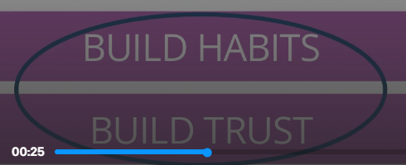
The next step is to BUILD HABITS. Set up safe online habits at home.  Plan phone-free times in your house, like during meals, homework, or in bed.  Set limits on the amount of time your child spends online.  Only let your child chat online with people they already know. They should never share personal information in a chat room or with strangers.  Before completing forms that ask for personal information, check that the web address begins with https://. Websites that begin with http:// may not be secure. | BUILD HABITS  - Set phone-free times in your house  - Check web addresses  https://  http:// | Animate to text
For older children, you can help them create strong passwords for their accounts. Good passwords are:  [pause] long  [pause] do not include obvious personal information like your name or birthday;  [pause] and include upper and lower case letters, numbers and symbols.  Tell your child not to click on pop-ups that ask them to download or pay for anything. | BUILD HABITS  Set Strong Passwords:  -Long  -Don’t include personal information  -DO include upper and lowercase letters, numbers, and symbols. | ^  Animate password details to explain better.
Finally, BUILD TRUST with your child  [1]  Together, look at the websites, social media, games, and apps they use.  [2]  Ask questions - this helps you learn more about your child's interests! | BUILD TRUST  - Look at websites, social media, games and apps that your child uses, together  - Ask questions | ^
If you come across anything worrying together, talk about it with your child. [1]If you need support, type HELP after you complete today’s lesson.  Tell your child that they should tell an adult if they feel scared, unsafe or upset about something online.  Teach your child that if a stranger offers gifts, like virtual coins, in exchange for photos and personal information, and tells them to keep it a secret, they should tell you.  Just as you keep your child safe in the real world, you also need to make sure they are safe in the digital world. By following these steps you can protect them and make sure that their online time is secure so they can keep using it to learn. You’re doing a great job! | BUILD TRUST  - Talk about worrying things together  - Tell your child if they feel scared or unsafe, they should tell an adult  HELP | ^  [1]Then, animate a phone with HELP on the screen with text.
Here’s something you can do with your child today to start making sure they stay safe online:  [1]  First, have a conversation with your child about how they can use the internet and devices in a safe way.  [2]  Next, talk about which sites or apps might be unsafe. Discuss why.  [3]  Finally, praise your child for how good they are at using the web!  Can you and your child complete this task today? | Build Habits and Trust Online  HOME ACTIVITY  - Have a conversation with your child about how they can use the internet and devices in a safe way.  - Talk about which sites or apps might be unsafe and why?  - Praise your child for how good they are at using the web safely!

